

|  |
| --- |
| CS 1103 – FR02B  Assignment 2 |
| Ngoc Phuong Anh Nguyen - 2712361  February 2021 |

# **Chapter Three Questions:**

## Review Questions:

### 1. What is the difference between a database and a table?

A database is a place to store tables and several other components, while a table is an object inside a database.

### 3. Why are entity integrity and referential integrity important in a database?

Entity integrity is crucial because it helps us to reference every row in a table and always receive results when we search for a specific row. And the failure to find a match on a row search will always mean that the row for which the search is conducted does not exist in that table.

Referential integrity is important because it makes sure that only a valid foreign key can be assigned to a table. You can not add an invalid value to the related table eliminating possible data entry errors that you might make.

### 8. Using the STUDENT and PROFESSOR tables in figure Q3.8, illustrate the difference between a natural join, an equijoin, and an outer join.

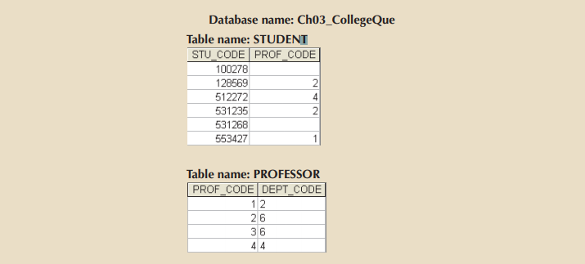

Figure Q3.8 The Ch03_CollegeQue database tables

|  |  |  |
| --- | --- | --- |
| **STU_CODE** | **PROF_CODE** | **DEPT_CODE** |
| 128569 | 2 | 6 |
| 512272 | 4 | 4 |
| 531235 | 2 | 6 |
| 553427 | 1 | 2 |

## Problems:

### Use the database shown in Figure P3.1 to answer Problems 1and 4.

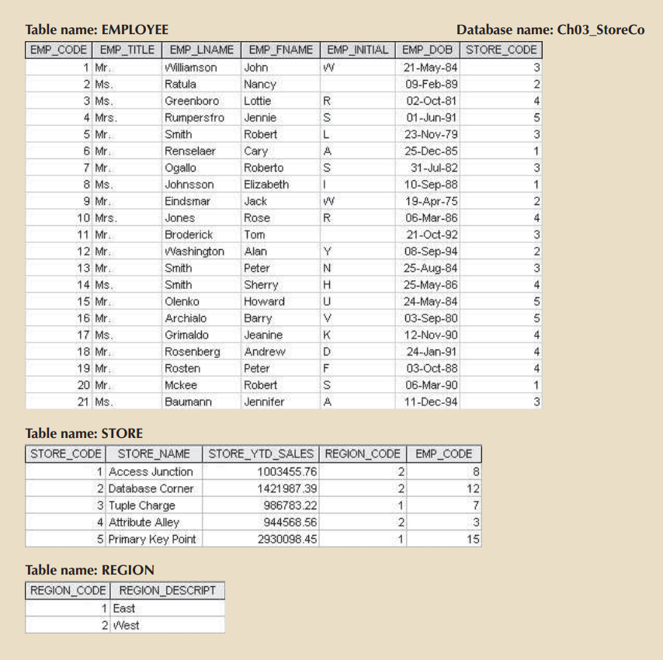

Figure P3.1 The Ch03_StoreCo database tables

### 1. For each table, identify the primary key and the foreign key(s). If a table does not have a foreign key, write *None.*

Table EMPLOYEE:

* Primary key: EMP_CODE
* Foreign key: STORE_CODE – It references to STORE_CODE in STORE table.

Table STORE:

* Primary key: STORE_CODE
* Foreign key: REGION_CODE – It references to REGION_CODE in REGION table.

Table STORE:

* Primary key: STORE_CODE
* Foreign key: None

### 4. Describe the type(s) of relationship(s) between STORE and REGION.

The relationship between STORE and REGION is many-to-one. Each store is set up in one and only one region, why each region can have one to many stores.

### 22. Use the database shown in Figure P3.17 to create the ERD for this database.

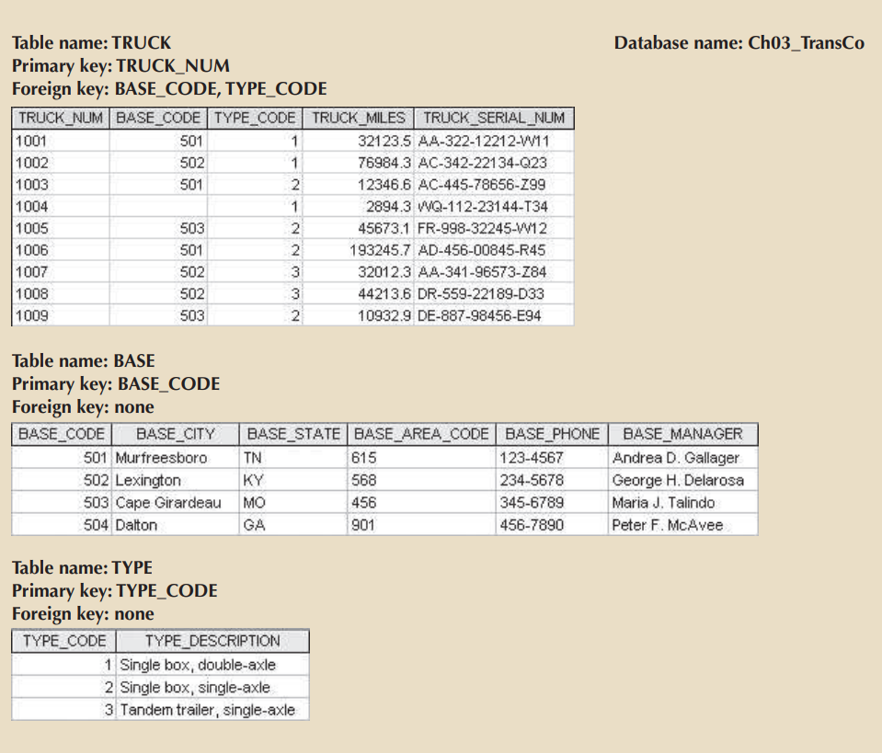

Figure P3.17 The Ch03_TransCo database tables

ER Diagram of Ch03_TransCo database

# Chapter Four Questions:

## Review Questions:

### 1. What two conditions must be met before an entity can be classified as a weak entity? Give an example of a weak entity.

* The entity should be “existence-dependent” on its parent entity.
  + If an entity is referred as an “entity-dependent”, then that entity can exist in the database if and only if when it is related with another entity existence.
* The entity should inherit a section of its primary key from its parent entity.

Example of a weak entity:

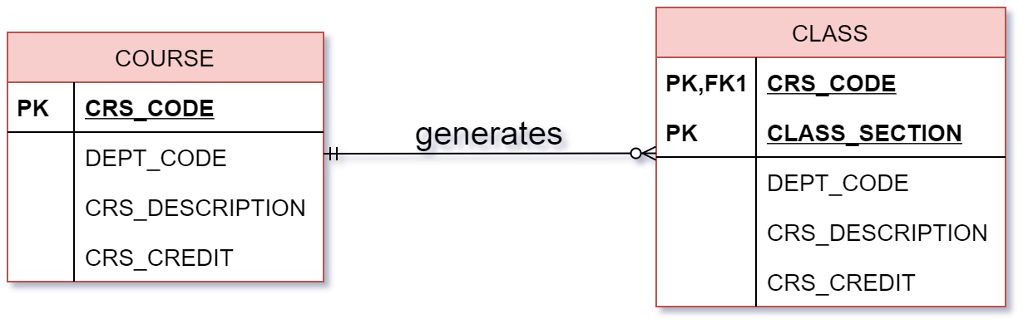

The CLASS entity is a weak entity because it is “existence-dependent” on COURSE entity. Therefore, the CLASS entity uses a primary key component from its parent entity (COURSE).

The primary keys of CLASS entity are CRS_CODE, CLASS_SECTION.

### 2. What is a strong (or identifying) relationship, and how is it depicted in a Crow’s Foot ERD?

A strong relationship exists when the primary key of the related entity contains a primary key component of the parent entity.

In a Crow’s Foot ERD, a strong relationship is depicted with a solid line between the entities.

### 4. What is a composite entity, and when is it used?

A composite entity is the one that has a primary key composed of multiple attributes.

Composite entity is used to transform many-to-many relationships to one-to-many relationships.

### 5a. Suppose you are working within the framework of the conceptual model in Figure Q4.5.

### Given the conceptual model in Figure Q4.5:

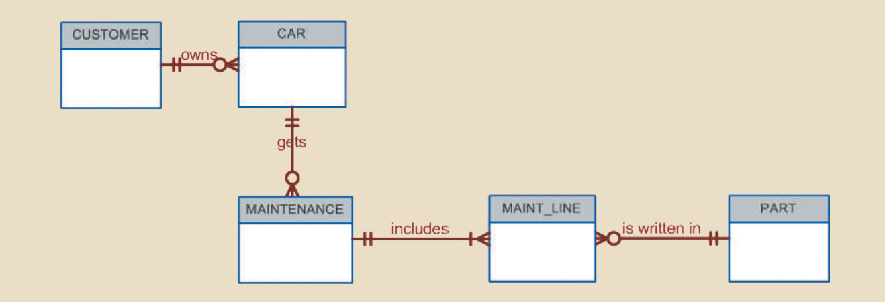

Figure Q4.5 The conceptual model for Question 5

### Write the business rules that are reflected in it.

Each customer owns many cars.

Some customers do not own car.

Each car is owned by one and only one customer.

A car can get many maintenance records.

Some cars have not got a maintenance record.

Each maintenance record is generated by only one car.

Each maintenance procedure includes one or many maintenance lines.

Each part may appear in many maintenance lines.

Each maintenance record can use many parts.

Each part is used in many maintenance records.

### 10. What is a derived attribute? Give an example. What are the advantages or disadvantages of storing or not storing a derived attribute?

A derived attribute is an attribute whose value is calculated from other attributes. It does not physically exist within the entity and is derived via an algorithm.

**The advantages or disadvantages of storing or not storing a derived attribute:**

|  |  |  |
| --- | --- | --- |
|  | **STORED** | **NOT STORED** |
| **Advantages** | * Saves CPU processing cycles * Saves data access time * Data value is readily available * Can be used to keep track of historical data | * Saves storage space * Computation always yields current value |
| **Disadvantages** | * Requires constant maintenance to ensure derived value is current, especially if any values used in the calculation change | * Uses CPU processing cycles * Increases data access time * Adds coding complexity to queries |

### 16. What are multivalued attributes, and how can they be handled within the database design?

Multivalued attribute is an attribute that has many values.

In order to be handled within the database design, the designer must decide on one of two possible courses of action:

* Create several new attributes, one for each component of the original multivalued attribute.
* Create a new entity composed of the original multivalued attribute’s components

## Problems:

### 1. Use the following business rules to create a Crow’s Foot ERD. Write all appropriate connectivities and cardinalities in the ERD.

* **A department employs many employees, but each employee is employed by only one department.**
* **Some employees, known as “rovers,” are not assigned to any department.**
* **A division operates many departments, but each department is operated by only one division.**
* **An employee may be assigned many projects, and a project may have many employees assigned to it.**
* **A project must have at least one employee assigned to it.**
* **One of the employees manages each department, and each department is managed by only one employee.**
* **One of the employees runs each division, and each division is run by only one employee.**

ER Diagram of Problem 1

### 4. Create an ERD based on the Crow’s Foot notation using the following requirements:

* **An INVOICE is written by a SALESREP. Each sales representative can write many invoices, but each invoice is written by a single sales representative.**
* **The INVOICE is written for a single CUSTOMER. However, each customer can have many invoices.**
* **An INVOICE can include many detail lines (LINE), each of which describes one product bought by the customer.**
* **The product information is stored in a PRODUCT entity. • The product’s vendor information is found in a VENDOR entity**

